Pokhara University

Level: Bachelor | Semester – Spring | Year : 2009
Programme: BE |  | Full Marks: 100
Course: Electronic Devices |  | Pass Marks: 45
 |  | Time : 3hrs.

Candidates are required to give their answers in their own words as far as practicable.
The figures in the margin indicate full marks.

Attempt all the questions.

 | - How can you say diode is a nonlinear device? Draw and explain the piecewise linear model equivalent circuit of diode.  - Describe the formation of p-n junction of semiconductor diode in both  - Forward bias condition  - Reverse bias condition | 8  7
 | - For the Zener diode network of the following figure Calculate;  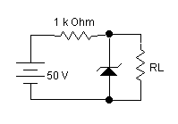  V_{i}=16V  1.2 K  1 K  V_{z}=10V  - Load voltage (V_{L})  - Current across Zener resistance (I_{Z})  - Voltage across resistance R = 1K  - Power across Zener diode (P_{Z})  b) Define depletion layer of a PN junction diode. Explain the formation of depletion layer in case of forward and reverse biasing of diode. | 8  7
 | - For the BJT common emitter circuit shown below, determine the operating point and locate it in the load line.  AC  59  K  3  K  1  .  5  K  5  .  9  K  50  µF  10  µF  10  µF  Vin  R_{L}=3K  +  20  V  β  =  150  - Describe the working principle of PNP transistor with necessary diagrams. Show that I_{C} = BI_{B} + (B+1) I_{C}B_{O}, where symbols have their usual meanings. | 8  7
 | - The following transistor circuit has given h-parameters  h_{ie}=1500 Ω, h_{fe}=80, h_{re}=2X10⁻⁴ and h_{oe}=20µs. Find (i)Z_{i} , (ii) r_{in} (stage), (iii) and (iv) Z₀ (stage). Explain the effect in voltage gain if R_{E} is un-bypassed.  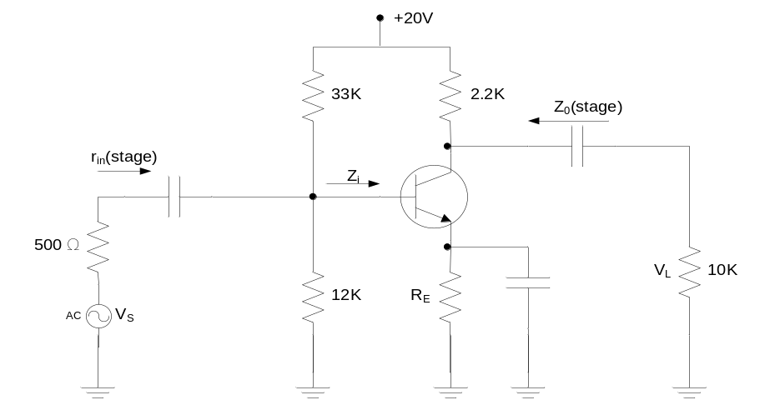  - For the network of figure, determine: (Given β = 90)  - Draw equivalent re model.  - re  - Input impedance (r_{in})  - Output impedance (r_{o})  - Voltage gain (Av) | 10  5
 | - Compare BJT and FET. Draw common source self bias n-JFET and draw its small signal low frequency model and derive its voltage gain.  - Design Voltage divider self bias n-JFET for 15 mA drain current and 20 V drain to source voltage. Given I_{DSS}= 25 mA and V_{P}= -12 V. | 8  7
 | - Draw Full wave bridge rectifier circuit and explain its operation. Compare half wave rectification & Full wave rectification in terms of Ripple factor, Efficiency & RMS value.  - Draw the output waveform for the following clipper circuit when input voltage V_{i} is applied to its input terminals.  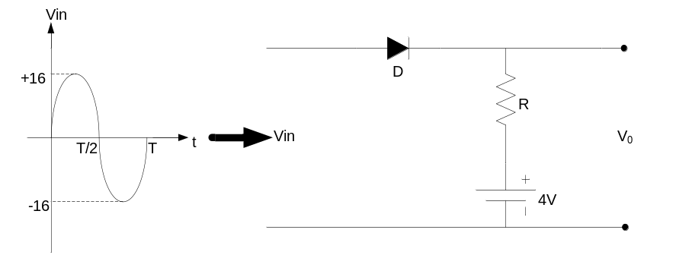 | 8  7
 | Write short notes on: (Any Two)  - High freqeuncy t-model  - MOSFET  - h(hybrid) parameters of BJT | 2×5

